**WEEKLY REPORT:**

1., Comparison of Arduino and 8051:

The Arduino platform and 8051 microcontrollers both serve important roles in embedded systems, but they differ in several significant ways. Here's a streamlined comparison to highlight their unique strengths and ideal use cases across various categories, including architecture, development environment, ease of use, hardware features, applications, and community support.

**A.** ARDUINO (Based on Architecture):

Types:

Often utilizes 8-bit AVR microcontrollers, such as the ATmega328P, or 32-bit ARM microcontrollers, like those in the Arduino Due.

- Architecture:

Based on RISC (Reduced Instruction Set Computer) principles.

-Clock Speed: Runs up to 16 MHz for AVR-based models and significantly higher for ARM-based models.

-Memory: Features distinct program and data memory spaces, providing enhanced flexibility

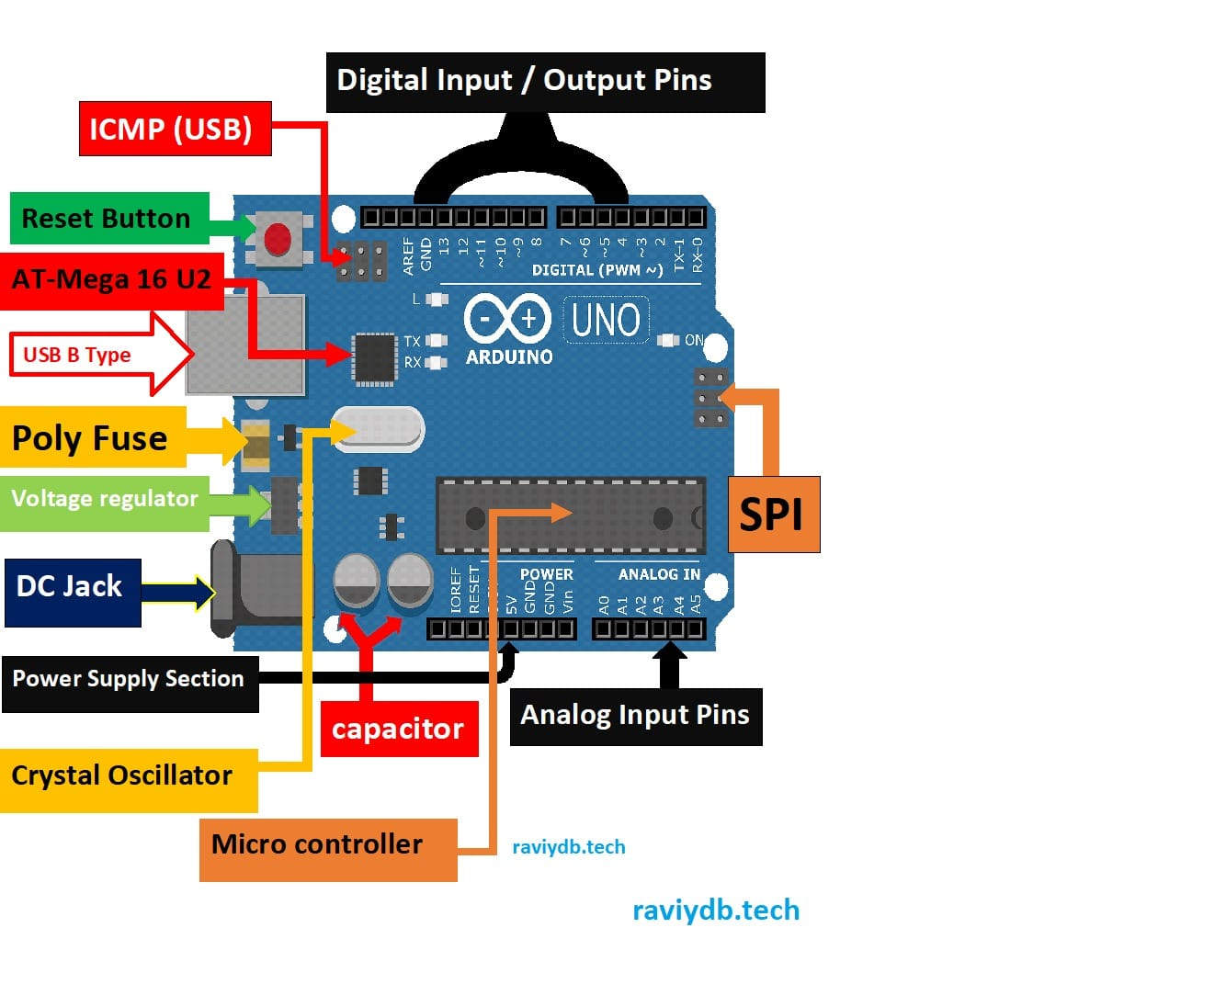

**B.**8051 Microcontroller (Based on architecture)

Type:

8-bit microcontroller.

* Architecture: CISC (Complex Instruction Set Computer).
* Clock Speed: Typically, up to 24 MHz

Memory: Separate program (ROM) and data (RAM) memory spaces (Harvard architecture).

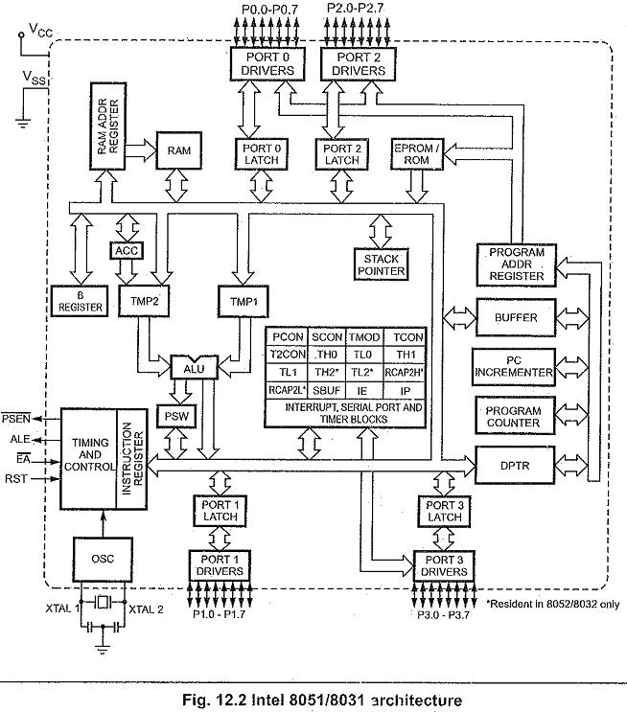

**2A.** ARDUINO (Based on hardware features):

Basic Features:

* Digital and analog I/O, PWM, UART, SPI, I2C.

Memory: Example (Arduino Uno) - 2 KB SRAM, 32 KB flash memory, 1 KB EEPROM.

I/O Pins: 14 digital I/O pins (6 PWM), 6 analog inputs. More on advanced models.

Expandability: Wide range of shields and modules for additional functionality.

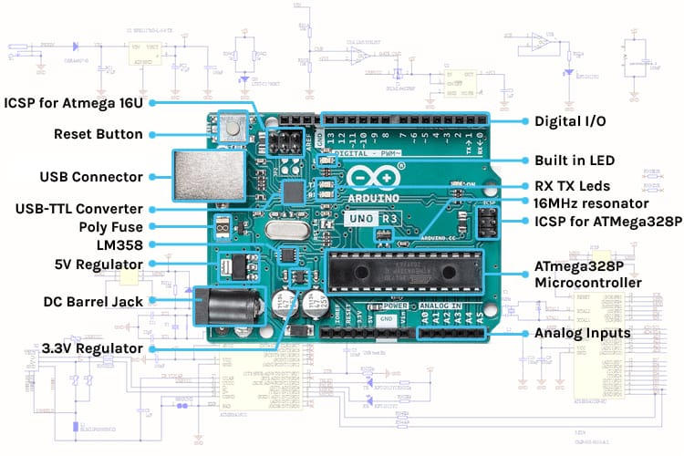

**2B.** 8051 Microcontroller (Based on hardware features):

Basic Features:

Timers, serial ports, interrupt systems.

Memory: Typically, 128 bytes of RAM, 4 KB of ROM.

I/O Pins: 32 I/O pins, with some variants offering additional peripherals.

Variants may include additional peripherals like ADCs, DACs, and PWM generators.

